Rameet Sandhu

Justin Jaunay

Chad Stone

Santino Milan

Nicholas Jurgens

Hongni Liu

**Project Phase 1**

Table of Contents

*Part I: Project Proposal & Project Planning*

*Part II: Competitive Strategy & Supply Chain Strategy*

*Part III: Supply Chain Structure (Drivers)*

*Part IV: Software Development Plan*

*Part V: Estimated Demand Data*

***Part I: Project Proposal & Project Planning***

1. **Define the Problem**
   1. Finalize the project proposal. This should include a clear statement of the goals and objectives of the project and a (tentative) supply chain for your actual product.
   2. Develop the competitive strategy and supply chain strategy.
   3. Design the high-level structure (drivers) for your supply chain.
   4. Develop a high-level plan for the software development part of your project.
   5. Obtain and estimate demand data for your product.
2. **Create a Plan**
   1. **Step 1:** Project Planning for Your Company’s Proposed New Product
      1. **Step 1.1:** Clearly state the intent of the project
      2. **Step 1.2:** Determine the design/development sub-tasks and activities
      3. **Step 1.3:** Create a design/development activity matrix purpose to understand the dependencies between the sub-task
      4. **Step 1.4:** Create a schedule of tasks using a GANTT chart
      5. **Step 1.5:** Identify the “critical path” for the project sing PERT chart
      6. **Step 1.6:** Assign clear roles and responsibilities for each subtasks/activities
   2. **Step 2:**
3. **Execute the Plan**
   1. **Step 1: Project Plan**
      1. **Step 1.1:** The intent of of the project is to create a smart trash can. Our company name is Purga. The smart trash can sort garbages, recycling, and compost into appropriate bins. The trash can has 5 bins, 1 for garbages, 2 for recycling, 1 for compost and 1 for waste.
      2. **Step 1.2:** Sub-tasks and activities
         1. **A**: Firm-up the project proposal
         2. **B**: Review problems on HW’s 1 and 2 to get some ideas for your project, developing the competitive strategy, supply-chain strategy, etc...
         3. **C**: Develop the overall supply chain strategy, and clearly state the logical used to determine this strategy.
         4. **D**: Design the high-level structure (drivers) for your supply chain
         5. **E**: Develop a high-level plan for the software development part of your project
         6. **F**: Obtain and/or estimate demand data for your product.
      3. **Step 1.3:** Activity Matrix

|  |  |  |  |  |  |  |
| --- | --- | --- | --- | --- | --- | --- |
|  | A | B | C | D | E | F |
| A | A |  |  |  |  |  |
| B |  | B |  |  |  |  |
| C | X |  | C |  |  |  |
| D | X |  |  | D |  |  |
| E | X |  |  |  | E |  |
| F | X |  | X | X | X | F |

Notation:

X = “depends on”

BxA = subtasks B depends on subtask A

* + 1. **Step 1.4:** Gantt Schedule

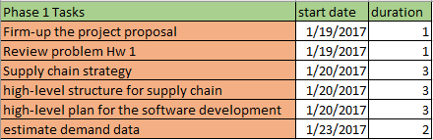

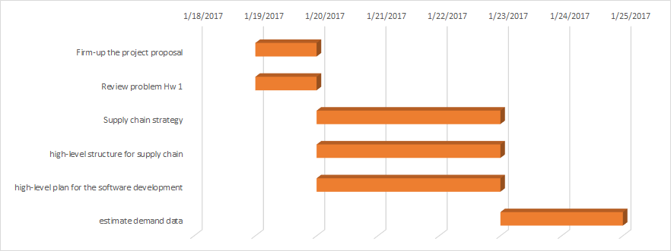

* + 1. **Step 1.5:** PERT chart



* + 1. **Step 1.6:** clear roles

|  |  |
| --- | --- |
| **Group Member** | **Role: (all include research)** |
| Rameet Sandhu | Supply chain strategy |
| Santino Milan | Estimate demand data, change excel |
| Justin Jaunay | Firm-up the project proposal, high-level plan for the software development |
| Nick Jurgens | High-level plan for the software development, high level structure for supply chain |
| Hongni Liu | Supply chain strategy |
| Chad Stone | High-level structure for supply chain |

1. **Draw Conclusions**

* Team will separate in groups of two and work together
  + Working together will allow a better overall work as partners can catch mistakes
* Two group meeting,
  + friday 1/20/2017
    - Discuss what groups need to work on in the weekend
  + monday 1/23/2017
    - Discuss what was worked on during the weekend

***Part II: Competitive Strategy & Supply Chain Strategy***

**Define the problem**

**Develop the overall supply chain strategy, and clearly state the logic used to determine this strategy.**

**Plan the Treatment:**

* 1. Step1:
     1. Understand customer needs
     2. Determine where the product lies in the life cycle
     3. Determine the IDU for the product
  2. Step 2
     1. For the given product establish the competitive strategy
     2. Determine the tradeoff between responsiveness & efficiency for the product based on the competitive strategy
     3. Map the resp/eff trade off onto or responsiveness/eff spectrum
  3. Step 3
     1. Create a 2-D space
        1. IDU spectrum is the X axis; Res/Eff spectrum is the Y axis
        2. Define a zone of strategic fit in this space
        3. Map a SC strategy for the product in the zone of strategic fit

**Execute the Plan:**

**Step 1:**

1. Customer needs:
   1. Ease of use
   2. Conceals smell
   3. Distributes waste correctly
   4. No noise pollution
   5. Sustains power life

*From last quarter Project Phase II*

1. Where does the product lies in the life-cycle?

**Life-cycle Chart of Purga**



*Figure 1b* shows us the life-cycle for Purga. It shows that Purga is at the beginning of the

life cycle since we still have to start getting suppliers and manufacture our product. Simplehuman another trashcan company is on the rise and is the most popular trashcan on the market today based off our research. We discovered that Simplehuman is the leading number 1 trashcan company out there today. Simplehuman was rated the top trashcan of the year because it made the most sales. iRobot has been on the decline with its products which are related to our product in the sense of technology used.

1. Implied demand Uncertainty (IDU) of our product

i. Smart Trash Can: High Implied Demand Uncertainty because our product has

just come out and we don’t know what the demand of our product will be.

***Introduction & Decline***: Give High IDU

***Growth***: Low IDU

***Maturity***: Gives Medium IDU

Since our product is in the beginning stages it will give High IDU because it is uncertain how our company will do with it’s product.



In *figure 1c* we see that Purga has high IDU and we have compared other smart trash can

companies who also have high IDU because they have just created their product and are

doing pre-orders before they manufacture their products. iRobot gives somewhat high IDU because it is in the decline and not many consumers are buying their products as opposed to Simplehuman which is another trashcan company which has low IDU because they are getting a lot of demand and number 1 in the trashcan market.

**Step 2:**

1. **Establish the competitive strategy**
   1. In order to be successful our company needs to have a competitive price for the smart trash can and make sure that it satisfy customer’s daily use.
   2. 
   3. Our company starts with high IDU then move toward to low IDU which indicates that the competitive strategy of our company shifts from Focus to Differentiated Strategy. As our product become more popular, we need to adjust our price because we will then start targeting different groups of people. Therefore in the future, our company’s competitive strategy is differentiated strategy.
2. **Determine the tradeoff between responsiveness & efficiency for the product based on the competitive strategy**
   1. SC Efficiency:
      1. Cost of making: $12 Million (This number is from TIM 105 Final Report)
      2. Sorting: Unknown
      3. Delivering the product to the customer: $235/container import from Mexico.
         1. http://acetool.commerce.gov/shipping
   2. SC Responsiveness:
      1. Customer need large changes in quantity demanded: Customer needs is the number 1 importance for us
         1. (HOQ TIM 105 Final Report)
      2. Large range of products (product variety): uncertainty/unknown
      3. High innovative products: Our software technology will constantly renew (see above)
      4. Short lead-times: may require long time production in advance
      5. High service levels: uncertainty/unknown
3. **Map the resp/eff trade off onto or responsiveness/eff spectrum**
   1. Responsiveness/Efficiency Spectrum



* Since it is a new product, so it will starts up with high efficiency. The production will require times to build the product. This product has recently been invented and new to the existing market. The production is narrow defined and can be scheduled in several months in advance. Also, figuring out the most responsive transportation would be a challenge and requires time to detect it.
  1. Responsiveness/Efficiency Map



* Since our company is new, our product will have high responsiveness and high uncertainty.

**Step 3:**

1. Create a 2-D space
   1. IDU spectrum is the X axis; Res/Eff spectrum is the Y axis
   2. Define a zone of strategic fit in this space
   3. Map a SC strategy for the product in the zone of strategic fit

(i+ii+iii below)



In the figure above you can see that Purga fall’s in the zone of strategic fit. Purga has a high IDU and also high responsiveness. This is because since Purga is a new company coming out the demand is uncertain for the newly released product but purga is quick to responding and adjusting demand to fit the needs of customers as well as having great customer service to becoming a successful company.

**Draw** **Conclusions**: We have analyzed our company’s supply chain strategy and have come to the conclusion that Purga will be at the beginning of the lifecycle because it is coming out with a new product trying to enter the market so the Implied Demand Uncertainty will be high compared to other companies that have been in the market and have a low IDU such as simplehuman, a company that makes the number one trash can as of today. Our products competitive strategy will be to have a differentiated products compared to other trashcan companies who have not come out with the idea we have proposed.

***Part III: Supply Chain Structure (Drivers)***

**Define the Problem:**

**Design the high-level structure (drivers) for your supply chain**

**Create a Plan:**

**Step 1:** Create a diagram of the five SC drivers for our company Purga.

**Step 2:** Explain each driver and the reason behind each decision.

**Execute the Plan:**

**Step 1:**



**Step 2:**

|  |  |
| --- | --- |
| **SC Drivers** | **Details** |
| Production | We will be building the smart trash can in the factory. Trash cans will be produced in anticipation of warehouse demand. |
| Inventory | Components   * Scanners * Disk * Sweeping Arm * Air Cannons * Trash Bins * Battery * CPU * Touch Screen Display |
| Location | We will have a factory based in Mexico because of the cheap manufacturing costs. We will also utilize Almo warehouses to distribute our product throughout the U.S. They have 8 strategically placed warehouses that will cut the transportation time to the customers. |
|
| Transportation | Our products and supplies will be shipped from our manufacturing and storage facilities in Mexico to the distributing facilities spread out across the U.S. using land and water transportation |
| Information | We will use SAP’s supply chain management software in order to maintain our shipment and orders. |

**Draw Conclusions:**

Overall we finalized all the different components which will be used for our product. In addition, we will place our storage and manufacturing facilities in Mexico. Our supplies and our product will be shipped using different modes of transportation including water and land. And lastly, all of our data and information analysis will be processed using SAP’s software technology.

***Part IV: Software Development Plan***

**Define the problem**

**Develop a High level plan for the software development part of your project**

**Plan the steps**

**Step 1:** Choosing which systems development methodology our team will use to try and achieve optimal efficiency for releasing our product on budget, and on time.

* Waterfall
* Rapid Application Development (RAD)
* Phased Development
* Prototyping
* Agile development

**Step 2:** Clearly define the steps to the systems development methodology that we chose. Explain the process in each step.

**Execute**

**Step 1:**

|  |  |  |  |
| --- | --- | --- | --- |
| **Methodology** | **Definition** | **Pros** | **Cons** |
| Waterfall | In this methodology, all the phases from requirement gathering and analysis, implementation, system design, testing, deployment to maintenance are done in a sequential manner. | * Timely completion * Transferring project knowledge is easier * Structured process * Better user experience * Detailed process of how work needs to be completed | * Difficult to make changes once the life cycle of the project reaches testing * Not suitable for complex projects (long/ongoing) * Unsuitable for projects where the possibility of changing requirements is high |
| Rapid Application Development (RAD) | This methodology uses minimal planning in favor of rapid prototyping. | * Measurable progress * Quickly generate productive code * Compartmentalization of system components * Rapid, constant user feedback * Early systems integration * Simple adaptability | * Requires modular systems * Difficulty within large-scale projects * Demands frequent user interfacing * Depends upon skilled developers |
| Phased Development | The whole requirement is divided into various builds. Each module passes through the requirements, design, implementation, and testing phases. A working version of software is produced during the first module, so you have working software early on during the software life cycle. | * Helps overcome resistance to change * Allows for lessons learned in early phases to be incorporated in systems installed in later phases * Establishes a solid foundation of available project-level data prior to rolling-up enterprise-level information | * Needs good planning and design * Needs a clear and complete definition of the whole system before it can be broken down and built incrementally * Total cost is high |
| Prototyping | In this methodology a prototype is built, tested, and then reworked as necessary until an acceptable prototype is finally achieved from which the complete system or product can now be developed. | * Users are actively involved in development * Users get a better understanding of the system being developed * Errors are easier to detect earlier * Quicker user feedback | * Leads to implementing and then repairing way of building systems * Increases complexity of the system * Incomplete application may cause the application to not perform as intended |
| Agile development | For the creative process that anticipates the need for flexibility and appliers a level of pragmatism into the delivery of the finished product. | * More flexibility compared to waterfall methodology * Iterations provide immediate feedback * Fewer detect in the final product | * Immediate feedback could result to scope creep * Documentation gets left behind |

We have chosen to go with the waterfall methodology because the specifications to our design are detailed and fixed, we do not have any ambiguous requirements to our system. The release of our system will be at the same time as the trashcan because it comes packaged together. Waterfall methodology allows us to release a concrete and finished product to our customers. We are confident that the product we wish to make will fit with the needs of our customers.

**Step 2:**



|  |  |  |
| --- | --- | --- |
| Steps to System Development Life Cycle | Define | How this correlates to our project |
| Planning | Fundamental process of understanding why an information system should be built and determining how the project team will go about building it.  Step 1: Project initiation, system value is defined  Step 2: Project is approved, enters project management | Step 1: Attempting to tap into the business of smart trashcan. Our estimated cost and potential revenue stream from this projects were defined in Phase 3 TIM 105  Step 2: Create a work plan, staff the project, and puts techniques into place to push the project ahead |
| Analysis | Answers the question of who will use the system, what the system will do, and where and when it will be used  Step 1: Analysis strategy, to guide the project team’s efforts  Step 2: Requirements gathering  Step 3: Analyses, system concept, and models are combined into the system proposal | The system will accurately sort through trash placed in the bin and place it in the correct compartment. It will be in the trashcan and be used by customers and cities  Step 1: Project planning, gantt and pert  Step 2: Researching on similar technologies, gathering information on sales and costs running from competitors  Step 3: Gathering of information into a proposal to be approved from system sponsor |
| Design | Phase that decides how the system will operate  Step 1: Design strategy  Step 2: Architecture design  Step 3: Database and file specifications  Step 4: Program design | Step 1: Group will decide from researching similar products if it is better to design the system inhouse or outsourcing  Step 2: Define the software architecture of the program and what technology it will be on  Step 3: The mechanism to sort trash will be stored on a chip in the device  Step 4:  -Program that identifies trash.  -Program that manipulates mechanical arm to place trash in correct location after being  -Program that opens and shuts bin to compartment of trash  -Program that displays how full the trash can is |
| Implementation | Building the system  Step 1: Construction of the system  Step 2: Installation of the system  Step 3: Establish a support plan | Step 1: Write Program detailed above, to perform all specific tasks needed for the trash can  Step 2: Install the chip into the Trashcan  Step 3: Create plan for possible changes to the overall system |
| Testing | Testing the system.  Step 1: Attempt to find a system problems  Step 2: Either fix or leave the problems found depending on seriousness of issues | Step 1: Testing performed on the trashcan, to be sure that all systems work well  Step 2: Major problems need to be addressed, minor problems can be left depending on how close to release date |
| Release | Step 1: Release the system  Step 2: Step up Help service | Step 1: Ship To distributors  Step 2: Organize phone operations to help customers |

**Draw Conclusions**

The goal was to find and decide on a methodology that would benefit the group working on the system. The system would need to be ready to put into the physical trashcan before the release of the overall product. For this reason we believed waterfall was the best methodology for this specific goal. The next point was to detail what each part of the methodology will do and how it will affect the project.

***Part V: Estimated Demand Data***

**Define the Problem:**

* In this section, we must begin to compile demand data for our product. To do this, we have to look at companies that sell similar products to our smart trashcan, and either directly obtain, or estimate, the appropriate data from which we can make reasonable estimations for our own product’s financial model.

**Plan the Problem:**

1. Identify at least 2 companies with similar products to ours.
2. From the companies identified, begin to analyze their financial statements.
   1. From available information, estimate market size.
   2. From available information, estimate sales.
3. After compiling and reviewing the appropriate numbers, state Purga’s expected demand.
   1. Conclude your work.

**Execute:**

For this section, we will be covering the following companies:

* **Poubelle LLC’s Bruno smart trash can.**
  + The Bruno smart trash can is currently still in its development phase, and the only numbers we can draw from come from their *Kickstarter* campaign.
  + According to their page, Poubelle was able to secure **665 supporters** over the course of **36 days**, and made **$117,240** in total from this single campaign.
  + The greatest problem with their numbers is the fact that the campaign took place from April 29, 2015 - June 4, 2015. They have struggled with their engineering, and as a result, haven’t been able to meet the scheduled delivery dates that they forecasted for consumers.
* **Uzer’s Eugene smart trash can.**
  + The Eugene smart trash can is also currently in the early development stages, and most of the available financial information comes from their “*kisskissbankbank”* campaign, which seems to be the French version of the kickstarter website.
  + According to the kisskissbankbank page, Uzer was able to secure **246 supporters** who donated a total of **€39,679** (approx. **$42,553**) over the course of **34 days**.
  + The campaign ended recently: June 9, 2016.
* **Bigbelly Solar smart trash can.**
  + Bigbelly’s solar smart trash can provide the most complete numbers, however the numbers are drawn strictly from their website, and not from any financial statements, as the company is privately owned.
  + According to their website, their trash cans are currently used by **1,600 organizations** in **47 nations** around the world, and can be found in **every state in the United States**.
  + Bigbelly reports that there are **over 30,000 of their trash can stations** throughout the world.
* **Conclusion**
  + Due to the fact that the market for the smart trash cans is still in the early stages of development, it’s difficult to assess potential customer demand for our product. Nevertheless, we will target consumers and organizations (school campuses, hospitals, cities, and etc.) and draw appropriate conclusions from the available data.
  + Given that both Eugene and Bruno met their fundraising goal in under 40 days (34 and 36 days, respectively,) there is reason to be optimistic about the number of consumers that Purga can sell to over the course of a full year. If Eugene and Bruno’s numbers were extended to include the rest of the year, they’d be on track to sell a combined 9,383 units. Purga should maintain a modest estimation of demand for their product, and seek to capture 20% of these sales, or approximately 1,876 units.
  + If Purga focuses strictly on selling to college campuses, the company could benefit greatly. According to a report from the National Center for Education Statistics, there were 9,452 campuses recognized in 2012-2013, in the United States alone. If our company targets a third of all the campuses in this country while selling 11 units per campus, we would see an increase demand of an additional 33,124 units.
    - This estimate does not include demand from other organizations who have shown interest in smart trash cans.
  + After reviewing the information above, Purga estimates to have a demand of approximately 35,000 units over the course of a year.

Excel Projections:

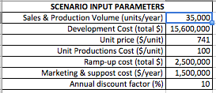

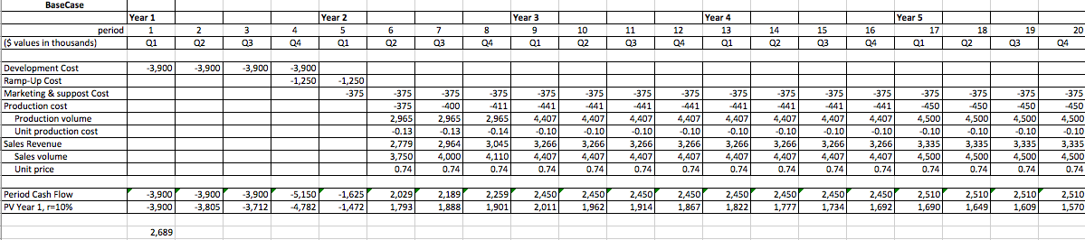

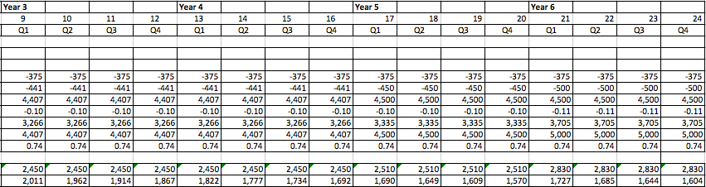

Sources:

Poubelle LLC & Bruno:

<https://www.kickstarter.com/projects/brunosmartcan/trash-can-vacuum-bruno-the-worlds-first-smartcan/updates>

<http://www.hoovers.com/company-information/cs/revenue-financial.poubelle_llc.b6e1ae1f19b138ad.html>

Uzer & Eugene:

<https://www.kisskissbankbank.com/eugene>

<https://www.yahoo.com/news/scan-garbage-barcode-smart-code-220828410.html>

Bigbelly Solar Smart Trash Can:

<http://www.astateherald.com/news/bigbelly-units-allow-for-smart-cost-efficient-recycling-on-campus/article_e370f37a-e233-11e4-9009-33d4f11b795c.html>

<http://www.housing.ucsb.edu/blog/smart-trash-big-belly-solar-powered-trash-compactors>

National Center for Education Statistics

<https://nces.ed.gov/fastfacts/display.asp?id=84>